

CYPRUS INTERNATIONAL UNIVERSITY
CMPE343
Database Management Systems and Programming I

Instructor: Dr. Mohammad

Ercan Airport database management system

Report Due Date: 24 May 2026

Group Members:
• Abubacar Sumalgy Junior - [22216839]
• Maham Samie - [22300391]

May 2026

Introduction

This project represents Ercan Airport Management database system designed to organize and manage information related to airplanes, hangars, employees, technicians, and aircraft testing procedures. The system stores important details such as airplane models and capacities, hangar locations, storage records, maintenance tests, and employee information. It also illustrates the relationships between different entities, including how airplanes undergo tests, how technicians perform those tests, and how airplanes are stored in hangars over time.

Er Diagram

The ER diagram represents the entities in the system and the relationships between them, including customers, menu items, orders, staff, dining tables, payments, and menu categories.
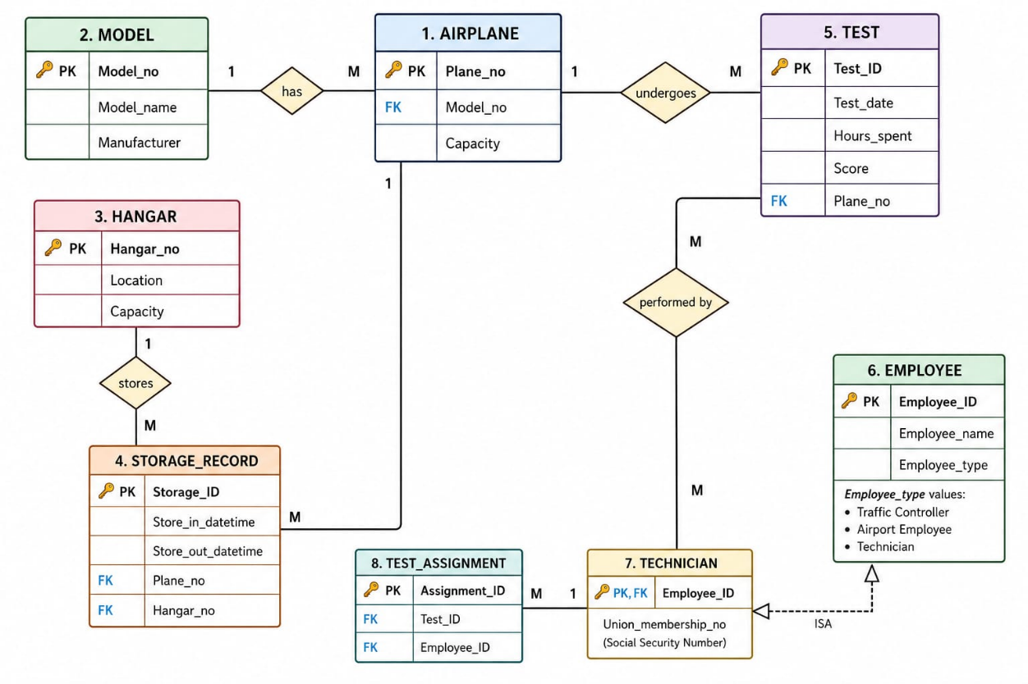

Relational model

Data Definition Language (DDL)

The database scheme was implemented using SQL and includes primary keys, foreign keys, constraints, and default values to ensure data integrity. The scheme defines related tables and enforces relationships between them using foreign key constraints.
The DDL code is:
DROP TABLE IF EXISTS technician_expertise;
DROP TABLE IF EXISTS testing_event;
DROP TABLE IF EXISTS hangar_assignment;
DROP TABLE IF EXISTS technician;
DROP TABLE IF EXISTS traffic_controller;
DROP TABLE IF EXISTS employee_union;
DROP TABLE IF EXISTS airport_employee;
DROP TABLE IF EXISTS union_;
DROP TABLE IF EXISTS airplane;
DROP TABLE IF EXISTS hangar;
DROP TABLE IF EXISTS test;
DROP TABLE IF EXISTS plane_model;

CREATE TABLE union_ (
union_id INT PRIMARY KEY AUTOINCREMENT,
union_name VARCHAR(100) NOT NULL UNIQUE,
contact_info VARCHAR(200),
established_date DATE,
monthly_fee NUMERIC(8,2) DEFAULT 0
);

CREATE TABLE airport_employee (
ssn VARCHAR(11) PRIMARY KEY,
full_name VARCHAR(120) NOT NULL,
address VARCHAR(250),
phone VARCHAR(20),
hire_date DATE NOT NULL DEFAULT CURRENT_DATE,
birth_date DATE,
gender CHAR(1),
email VARCHAR(100) UNIQUE
);

CREATE TABLE employee_union (
ssn VARCHAR(11) NOT NULL,
union_id INTEGER NOT NULL,
membership_number VARCHAR(50) NOT NULL UNIQUE,
join_date DATE NOT NULL DEFAULT CURRENT_DATE,
is_active BOOLEAN DEFAULT TRUE,
PRIMARY KEY (ssn, union_id),
FOREIGN KEY (ssn) REFERENCES airport_employee(ssn) ON UPDATE CASCADE ON DELETE CASCADE,
FOREIGN KEY (union_id) REFERENCES union_(union_id) ON UPDATE CASCADE ON DELETE RESTRICT
);

CREATE TABLE technician (
ssn VARCHAR(11) PRIMARY KEY,
specialization VARCHAR(100),
years_of_experience INTEGER DEFAULT 0,
certification_level VARCHAR(20),
hourly_rate NUMERIC(10,2) DEFAULT 0,
FOREIGN KEY (ssn) REFERENCES airport_employee(ssn) ON UPDATE CASCADE ON DELETE CASCADE
);

CREATE TABLE traffic_controller (
ssn VARCHAR(11) PRIMARY KEY,
last_medical_exam_date DATE NOT NULL,
tower_assignment VARCHAR(50),
certification_number VARCHAR(50) UNIQUE,
shift_schedule VARCHAR(50),
FOREIGN KEY (ssn) REFERENCES airport_employee(ssn) ON UPDATE CASCADE ON DELETE CASCADE
);

CREATE TABLE plane_model (
model_no VARCHAR(30) PRIMARY KEY,
manufacturer VARCHAR(60) NOT NULL,
type VARCHAR(50) NOT NULL,
typical_capacity INT,
max_range_km INT,
cruise_speed_kmh INT
);

CREATE TABLE technician_expertise (
technician_ssn VARCHAR(11) NOT NULL,
model_no VARCHAR(30) NOT NULL,
expertise_level VARCHAR(20) DEFAULT 'Certified',
certification_date DATE NOT NULL DEFAULT CURRENT_DATE,
PRIMARY KEY (technician_ssn, model_no),
FOREIGN KEY (technician_ssn) REFERENCES technician(ssn) ON UPDATE CASCADE ON DELETE CASCADE,
FOREIGN KEY (model_no) REFERENCES plane_model(model_no) ON UPDATE CASCADE ON DELETE CASCADE
);

CREATE TABLE hangar (
hangar_no VARCHAR(20) PRIMARY KEY,
location VARCHAR(100) NOT NULL,
capacity INT,
has_fire_suppression BOOLEAN DEFAULT FALSE,
has_lighting BOOLEAN DEFAULT TRUE
);

CREATE TABLE airplane (
plane_no VARCHAR(20) PRIMARY KEY,
model_no VARCHAR(30) NOT NULL,
current_hangar_no VARCHAR(20),
status VARCHAR(20) DEFAULT 'Active',
acquisition_date DATE ,
last_maintenance_date DATE,
total_flight_hours INT,
FOREIGN KEY (model_no) REFERENCES plane_model(model_no) ON UPDATE CASCADE ON DELETE RESTRICT,
FOREIGN KEY (current_hangar_no) REFERENCES hangar(hangar_no) ON UPDATE CASCADE ON DELETE SET NULL
);

CREATE TABLE hangar_assignment (
assignment_id INT PRIMARY KEY AUTOINCREMENT,
plane_no VARCHAR(20) NOT NULL,
hangar_no VARCHAR(20) NOT NULL,
in_date DATE NOT NULL,
in_time TIME NOT NULL,
out_date DATE,
out_time TIME,
reason VARCHAR(100),
FOREIGN KEY (plane_no) REFERENCES airplane(plane_no) ON UPDATE CASCADE ON DELETE CASCADE,
FOREIGN KEY (hangar_no) REFERENCES hangar(hangar_no) ON UPDATE CASCADE ON DELETE RESTRICT
);

CREATE TABLE test (
test_id INT PRIMARY KEY AUTOINCREMENT,
test_name VARCHAR(100) NOT NULL UNIQUE,
description TEXT,
duration_hours NUMERIC(5,2) NOT NULL,
frequency_days INT,
passing_score INT
);

CREATE TABLE testing_event (
event_id INT PRIMARY KEY AUTOINCREMENT,
plane_no VARCHAR(20) NOT NULL,
technician_ssn VARCHAR(11) NOT NULL,
test_id INT NOT NULL,
test_date DATE NOT NULL,
test_time TIME NOT NULL,
hours_spent NUMERIC (5,2) NOT NULL,
score INT,
remarks TEXT,
FOREIGN KEY (plane_no) REFERENCES airplane(plane_no) ON UPDATE CASCADE ON DELETE RESTRICT,
FOREIGN KEY (technician_ssn) REFERENCES technician(ssn) ON UPDATE CASCADE ON DELETE RESTRICT,
FOREIGN KEY (test_id) REFERENCES test(test_id) ON UPDATE CASCADE ON DELETE RESTRICT,
UNIQUE (plane_no, test_id, test_date)
);

Data Manipulation Language (DML)

Sample data was inserted into all tables using SQL INSERT statements. UPDATE and DELETE operations were also performed to demonstrate data modification and removal.
The DML code is:

INSERT INTO union_ (union_name, contact_info, established_date, monthly_fee) VALUES
('Airport Workers Union TRNC', 'contact@awu.trnc', '1985-03-15', 50.00),
('Aviation Technicians Guild', 'info@atg.trnc', '1990-07-22', 75.00),
('Air Traffic Controllers Association', 'atca@ercan.trnc', '1978-11-10', 60.00);

INSERT INTO plane_model (model_no, manufacturer, type, typical_capacity, max_range_km, cruise_speed_kmh) VALUES
('B737-800', 'Boeing', 'Narrow-body', 189, 5400, 842),
('A320-200', 'Airbus', 'Narrow-body', 180, 6150, 828),
('B777-300ER', 'Boeing', 'Wide-body', 354, 13650, 905),
('B787-9', 'Boeing', 'Wide-body', 290, 14140, 903);

INSERT INTO airport_employee (ssn, full_name, address, phone, hire_date, birth_date, gender, email) VALUES
('12345678901', 'Hakan Şükür', 'Lefkosa, TRNC', '+90-533-111-2233', '2010-06-15', '1971-09-01', 'M', 'hakan.sukur@ercan.trnc'),
('23456789012', 'Arda Turan', 'Girne, TRNC', '+90-542-222-3344', '2012-09-20', '1987-01-30', 'M', 'arda.turan@ercan.trnc'),
('34567890123', 'Burak Yılmaz', 'Guzelyurt, TRNC', '+90-533-333-4455', '2015-03-10', '1985-07-15', 'M', 'burak.yilmaz@ercan.trnc'),
('56789012345', 'Tuncay Şanlı', 'Girne, TRNC', '+90-533-555-6677', '2008-11-01', '1982-01-16', 'M', 'tuncay.sanli@ercan.trnc'),
('67890123456', 'Fatih Terim', 'Lefkosa, TRNC', '+90-542-666-7788', '2020-06-20', '1953-09-04', 'M', 'fatih.terim@ercan.trnc'),
('78901234567', 'Rüştü Reçber', 'Magusa, TRNC', '+90-533-777-8899', '2005-09-25', '1973-05-10', 'M', 'rustu.recber@ercan.trnc'),
('89012345678', 'Hamit Altıntop', 'Lefkosa, TRNC', '+90-548-888-9900', '2019-03-18', '1982-12-08', 'M', 'hamit.altintop@ercan.trnc'),
('01234567890', 'Gökhan Gönül', 'Lefkosa, TRNC', '+90-542-111-2233', '2016-12-05', '1985-01-04', 'M', 'gokhan.gonul@ercan.trnc');

INSERT INTO technician (ssn, specialization, years_of_experience, certification_level, hourly_rate) VALUES
('12345678901', 'Engine Specialist', 14, 'Master', 85.00),
('23456789012', 'Avionics Engineer', 12, 'Senior', 70.00),
('34567890123', 'Airframe Specialist', 9, 'Senior', 65.00),
('56789012345', 'Maintenance Engineer', 16, 'Master', 90.00);

INSERT INTO traffic_controller (ssn, last_medical_exam_date, tower_assignment, certification_number, shift_schedule) VALUES
('67890123456', '2025-06-15', 'Main Tower', 'ATC-TRNC-001', 'Morning Shift'),
('78901234567', '2025-05-20', 'Main Tower', 'ATC-TRNC-002', 'Night Shift'),
('89012345678', '2025-04-10', 'Approach Control', 'ATC-TRNC-003', 'Evening Shift');

INSERT INTO employee_union (ssn, union_id, membership_number, join_date, is_active) VALUES
('12345678901', 2, 'ATG-1001', '2010-07-01', 1),
('23456789012', 2, 'ATG-1002', '2012-10-05', 1),
('34567890123', 2, 'ATG-1003', '2015-04-20', 1),
('56789012345', 2, 'ATG-1005', '2008-12-15', 1),
('67890123456', 3, 'ATCA-2001', '2020-07-15', 1),
('78901234567', 3, 'ATCA-2002', '2005-10-01', 1),
('89012345678', 3, 'ATCA-2003', '2019-04-01', 1);

INSERT INTO technician_expertise (technician_ssn, model_no, expertise_level, certification_date) VALUES
('12345678901', 'B737-800', 'Master', '2012-06-20'),
('12345678901', 'B787-9', 'Expert', '2016-08-15'),
('23456789012', 'A320-200', 'Expert', '2014-09-10'),
('34567890123', 'B737-800', 'Expert', '2016-03-15'),
('34567890123', 'B777-300ER', 'Certified', '2018-07-22'),
('56789012345', 'B777-300ER', 'Master', '2010-12-01'),
('56789012345', 'B787-9', 'Expert', '2015-04-18');

INSERT INTO hangar (hangar_no, location, capacity, has_fire_suppression, has_lighting) VALUES
('H-01', 'North Section - Terminal A - Ercan Airport', 8, 1, 1),
('H-02', 'South Section - Maintenance Area - Ercan Airport', 12, 1, 1),
('H-03', 'East Section - Cargo Area - Ercan Airport', 6, 0, 1);

INSERT INTO airplane (plane_no, model_no, current_hangar_no, status, acquisition_date, last_maintenance_date, total_flight_hours) VALUES
('TC-ABC', 'B737-800', 'H-01', 'Active', '2018-03-10', '2025-11-15', 8500),
('TC-DEF', 'A320-200', 'H-02', 'Active', '2019-06-20', '2025-11-20', 6200),
('TC-GHI', 'B777-300ER', 'H-03', 'In Maintenance', '2016-09-15', '2025-10-25', 18500),
('TC-JKL', 'B787-9', 'H-01', 'Active', '2021-04-05', '2025-11-05', 3100);

INSERT INTO hangar_assignment (plane_no, hangar_no, in_date, in_time, out_date, out_time, reason) VALUES
('TC-ABC', 'H-01', '2024-01-10', '08:00:00', '2024-06-15', '14:30:00', 'Regular Parking'),
('TC-ABC', 'H-01', '2024-06-15', '15:00:00', NULL, NULL, 'Return to Service'),
('TC-DEF', 'H-02', '2024-03-01', '09:00:00', NULL, NULL, 'Regular Parking'),
('TC-GHI', 'H-03', '2024-02-15', '07:00:00', NULL, NULL, 'Major Overhaul'),
('TC-JKL', 'H-01', '2024-05-01', '11:00:00', NULL, NULL, 'Regular Parking');

INSERT INTO test (test_name, description, duration_hours, frequency_days, passing_score) VALUES
('Engine Performance Test', 'Comprehensive engine thrust and efficiency test', 4.5, 180, 85),
('Avionics Systems Check', 'Testing navigation and communication systems', 3.0, 90, 90),
('Emergency Systems Test', 'Testing all emergency equipment', 2.0, 180, 95),
('Landing Gear Operation', 'Full cycle landing gear deployment test', 2.5, 120, 85);

INSERT INTO testing_event (plane_no, technician_ssn, test_id, test_date, test_time, hours_spent, score, remarks) VALUES
('TC-ABC', '12345678901', 1, '2025-11-15', '09:00:00', 4.0, 92, 'Excellent performance'),
('TC-ABC', '23456789012', 2, '2025-11-10', '13:30:00', 2.5, 88, 'Minor calibration needed'),
('TC-DEF', '34567890123', 4, '2025-11-08', '14:00:00', 2.0, 90, 'Smooth operation'),
('TC-GHI', '56789012345', 1, '2025-10-25', '08:30:00', 4.5, 65, 'Engine needs overhaul'),
('TC-GHI', '56789012345', 3, '2025-10-26', '11:00:00', 2.0, 82, 'Emergency systems OK'),
('TC-JKL', '12345678901', 2, '2025-11-01', '15:00:00', 2.8, 95, 'All systems nominal');

UPDATE airplane SET status = 'Active', last_maintenance_date = DATE('now') WHERE plane_no = 'TC-GHI';
UPDATE airplane SET current_hangar_no = 'H-02' WHERE plane_no = 'TC-DEF';
INSERT INTO hangar_assignment (plane_no, hangar_no, in_date, in_time, reason) VALUES ('TC-DEF', 'H-02', DATE('now'), TIME('now'), 'Relocation for maintenance');
UPDATE technician SET hourly_rate = hourly_rate * 1.10 WHERE certification_level = 'Master';
UPDATE traffic_controller SET last_medical_exam_date = DATE('now') WHERE ssn = '78901234567';
UPDATE test SET passing_score = passing_score + 5 WHERE test_name = 'Engine Performance Test';
UPDATE airplane SET total_flight_hours = total_flight_hours + 500 WHERE status = 'Active';
DELETE FROM hangar_assignment WHERE out_date IS NOT NULL AND out_date < DATE('now', '-2 years');

SQL queries:
Q1: List all airplanes with their model details and current hangar
Uses: Join
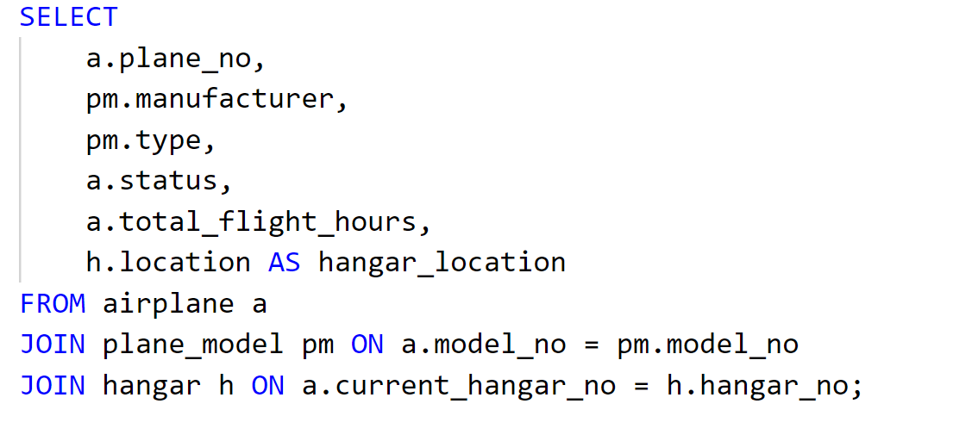

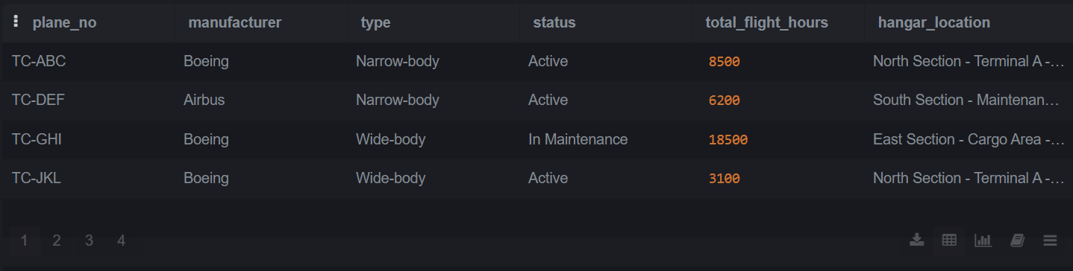

Q2: Show all testing events with airplane, technician name and test name
Uses: Join(multiple)
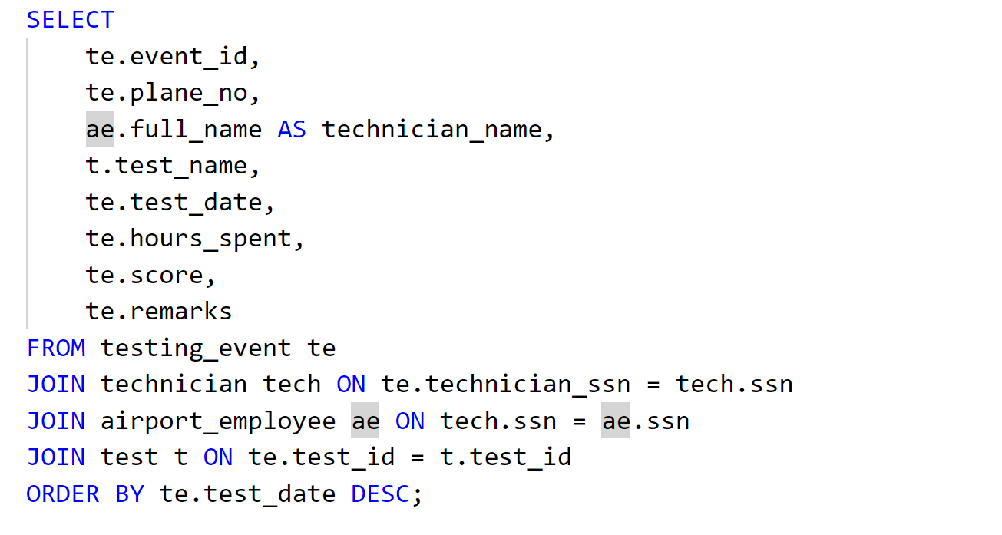

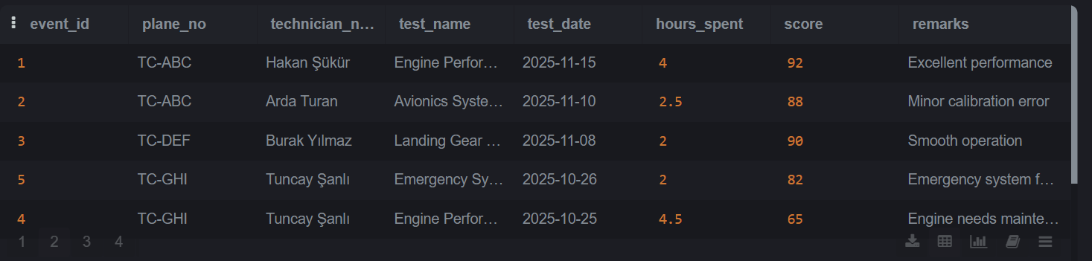

Q3: Total hours each technician has spent on tests
Uses: Join, Group By
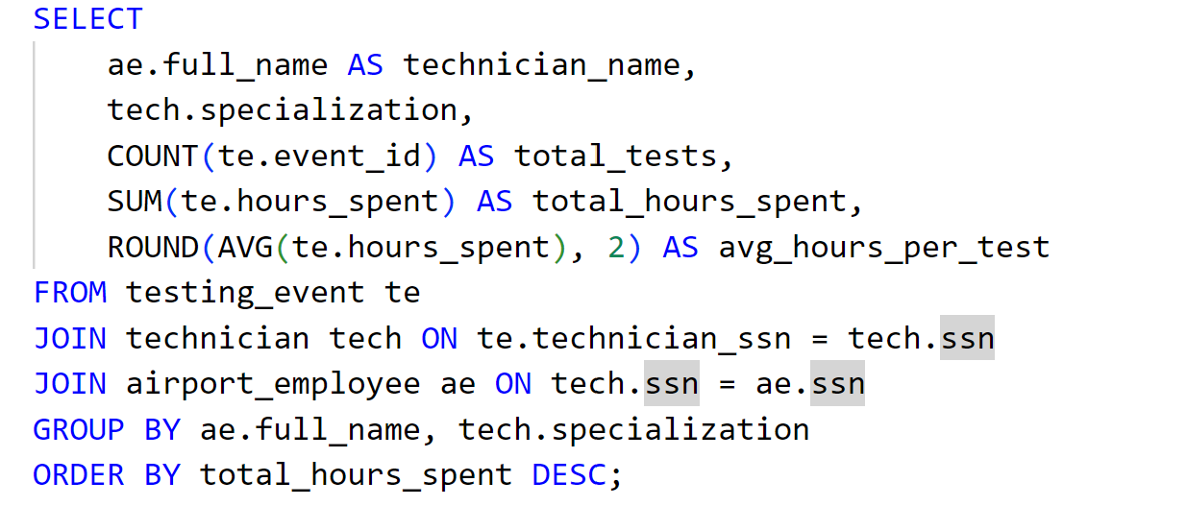
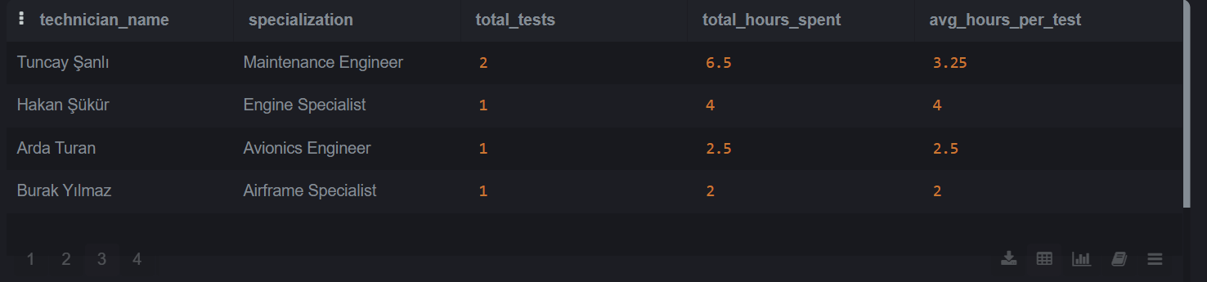

Q4: Average test score per airplane
Uses: Join, Group By
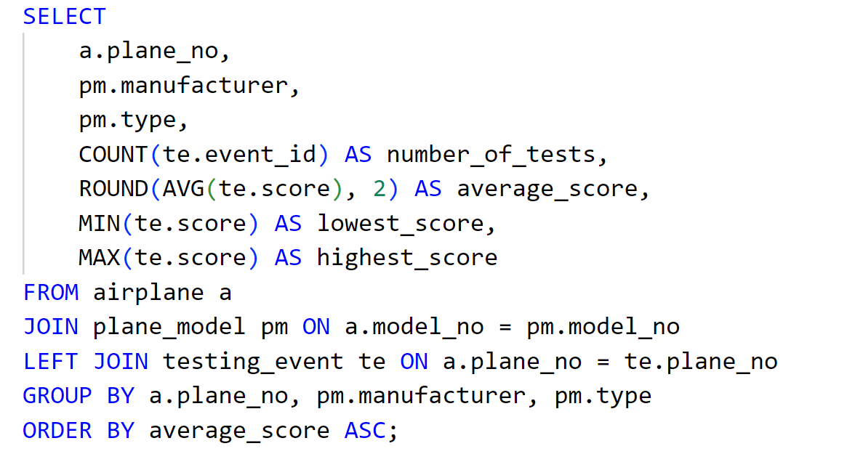
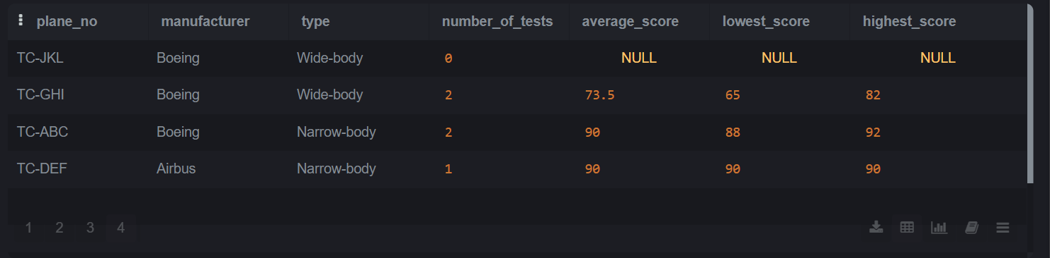

Q5: Airplanes that have failed at least one test
Uses: Join, Subquery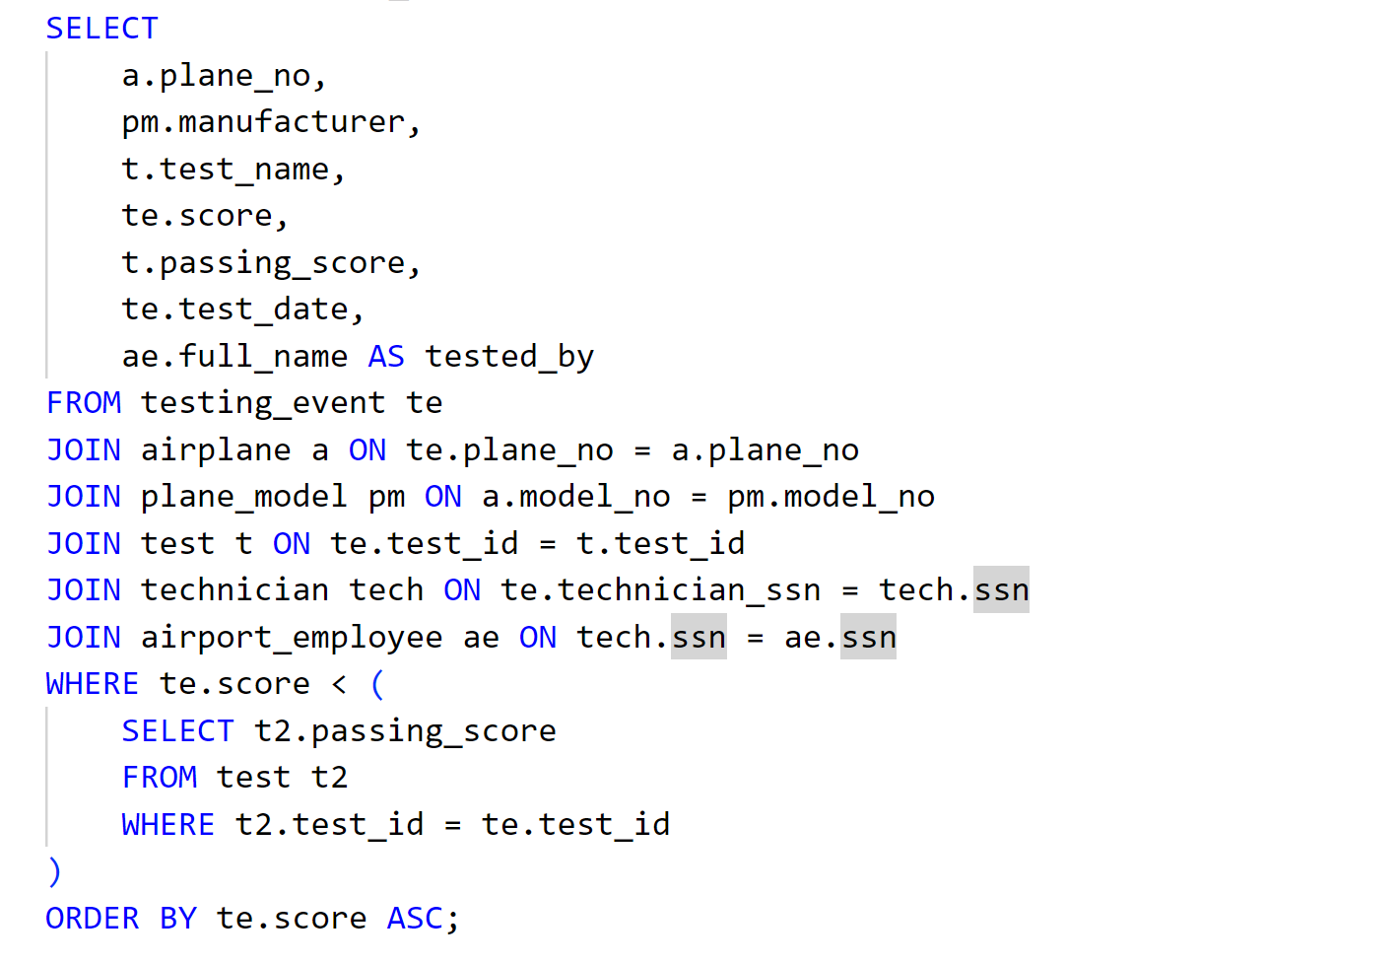
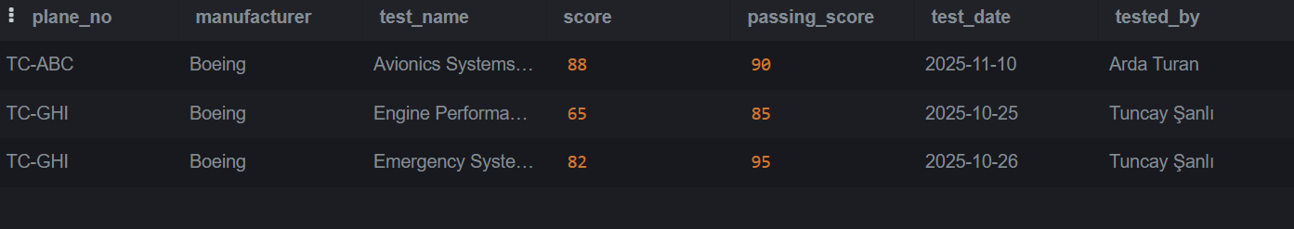
Q6: Number of airplanes currently stored in each hangar
Uses: Join, Group By
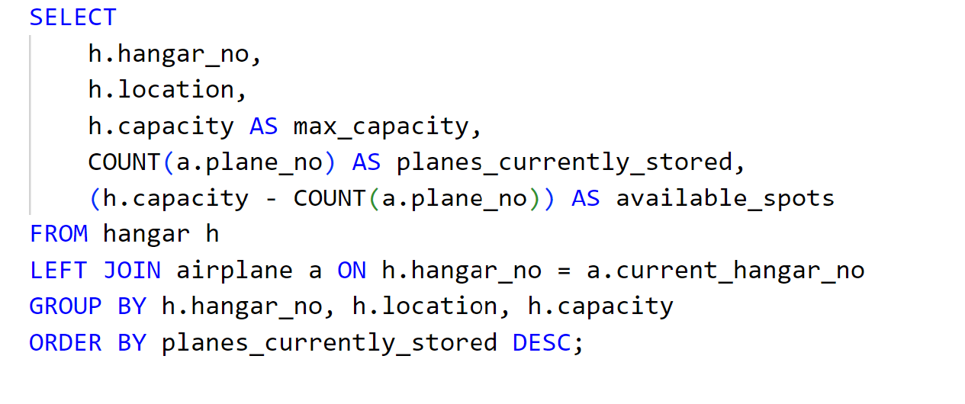
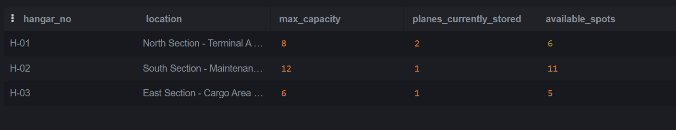

Q7: Traffic controllers whose medical exam is older than 1 year
Uses: Join
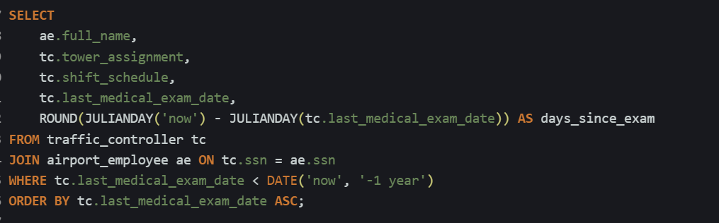
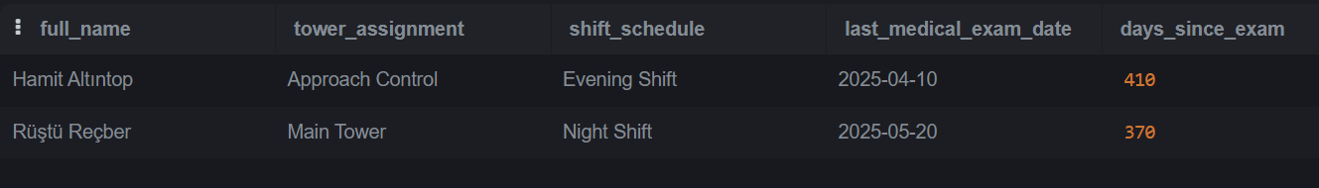

Q8:List all technicians and the plane models they are certified for
Uses: Join, Group By
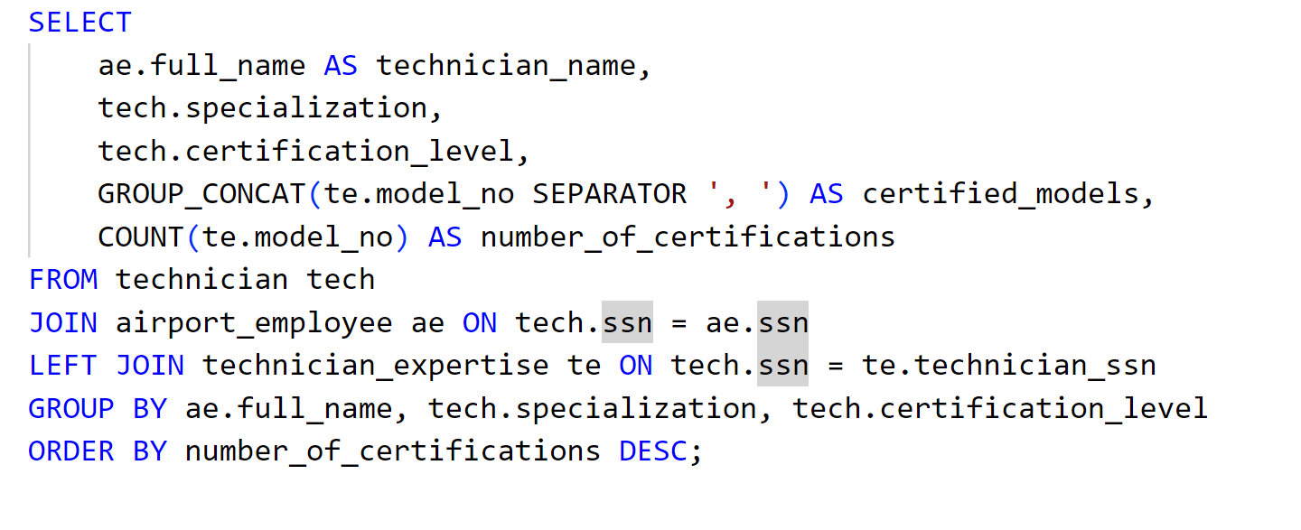
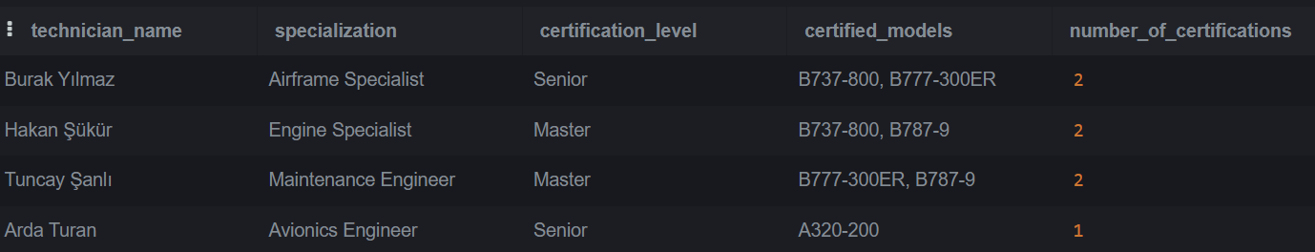
Q9: Technicians certified for more than one plane model
Use: Join, Group By, Subquery
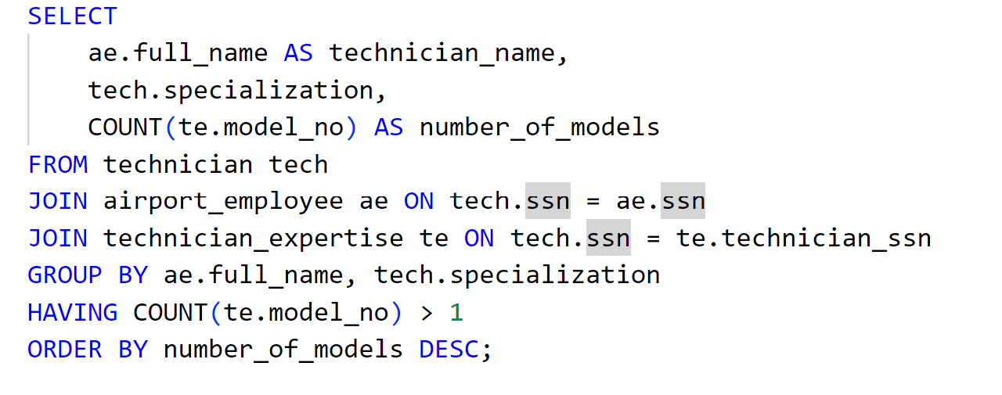
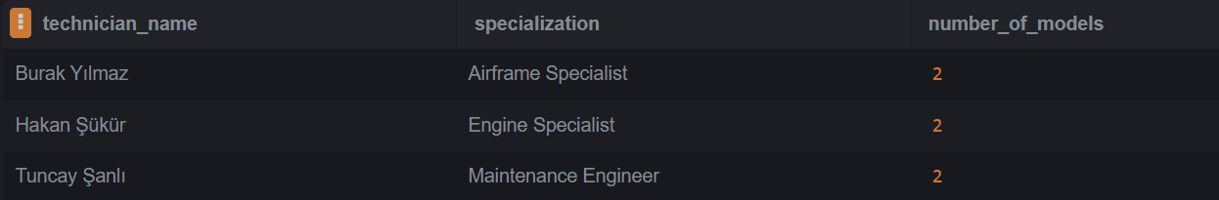

Q10: Full hangar history for each airplane with formatted dates
Uses: Join, DATE_FORMAT
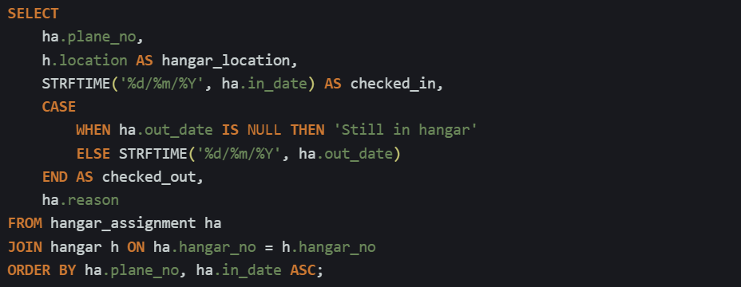
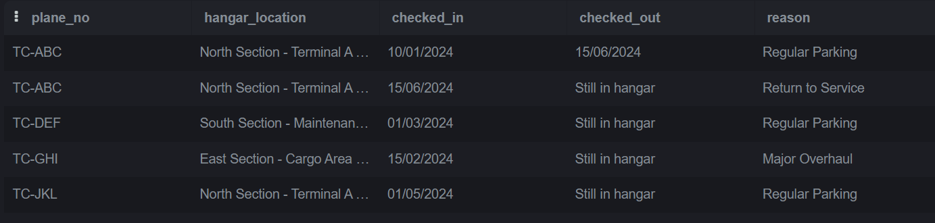

Q11: Most frequently used tests
Uses: Join, Group By
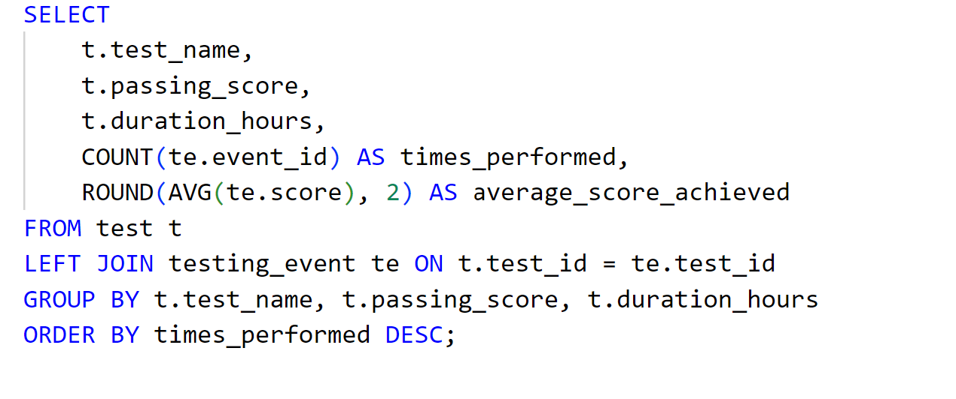
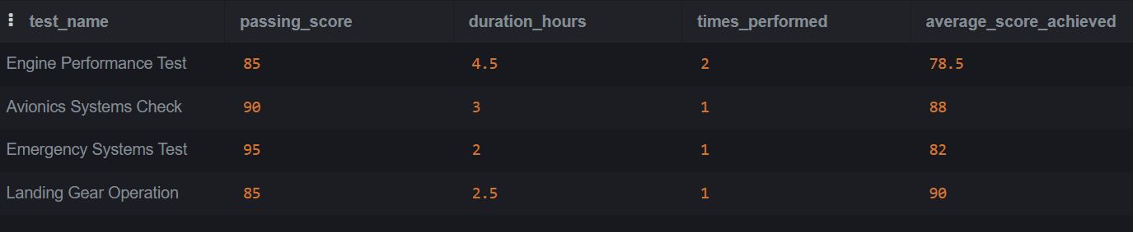

Q12: Employees who are NOT in any union
Uses: Subquery
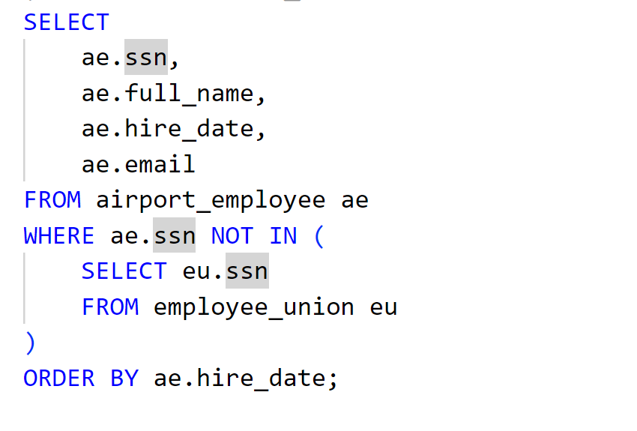

Q13: Monthly testing activity report
Uses: Group by, Date_Format
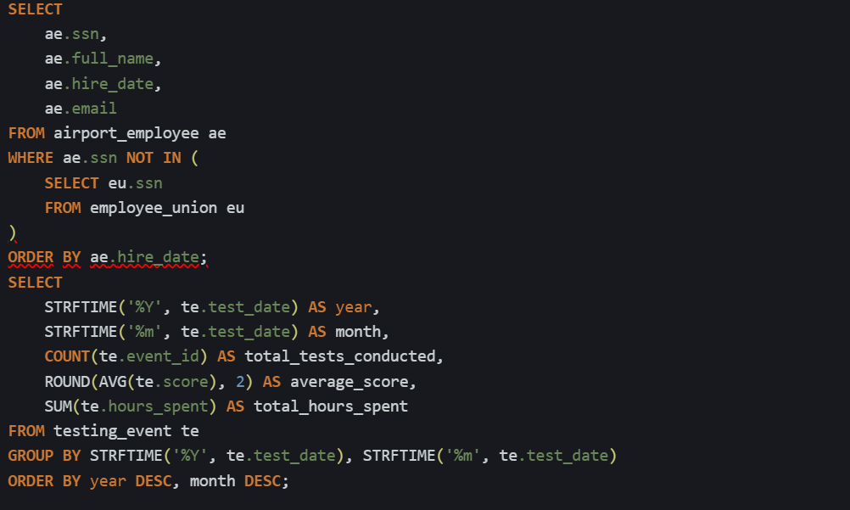
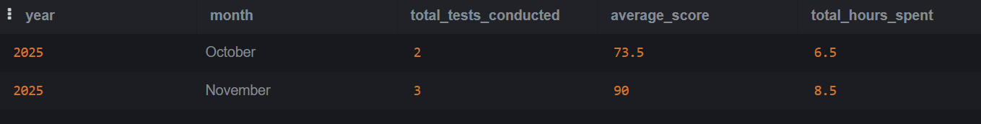
Q14: Airplanes that have never been tested
Uses: Subquery
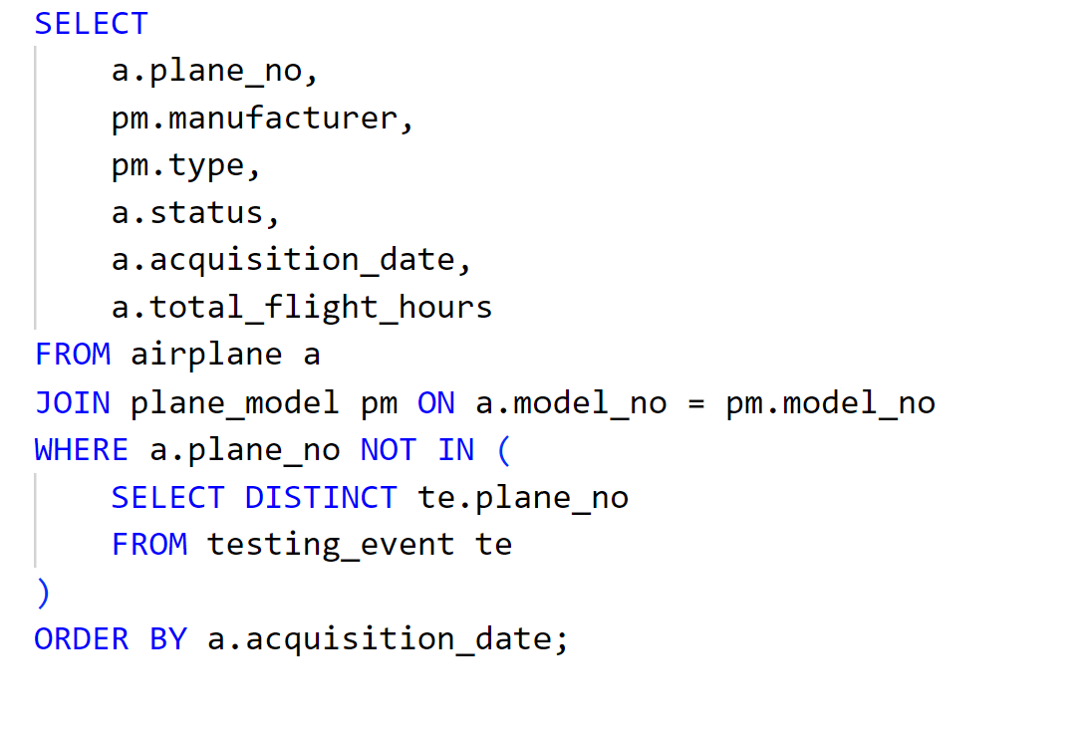
Q15: Technician cost report; total pay per technician based on hours spent
Uses: Join, Group By
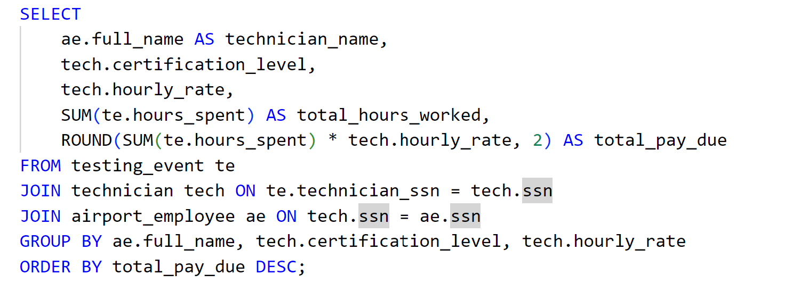
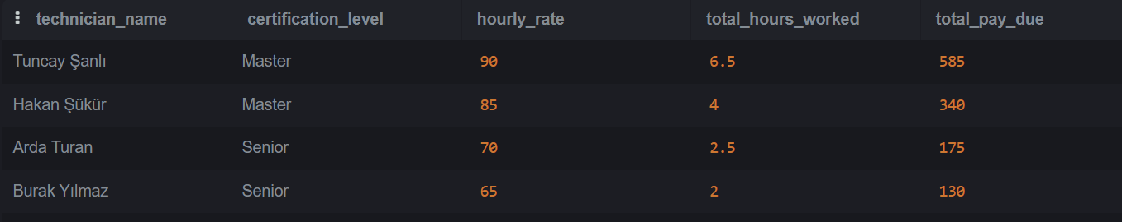

SQL queries table:

